listeningpart1no1dan2.mp3 (open link in new tab)
Question 1
PART 1 (Questions 1-8). Listen to the conversation and choose the correct answer A,B, or C. You will hear the extract TWICE. You will hear a man on the radio talking about his son. Why does his son want to become a computer games designer?
Select one:
a. for the money
b. for the excitement
c. for the challenge

Question 2
You will hear a student talking about her career. What is she planning to do next?
Select one:
a. stay at college
b. start her own business
c. train with an expert

listeningpart1no3dan4.mp3
Question 3
You will hear a man talking to his daughter. Why is he talking to her?
Select one:
a. to offer to help her
b. to give her some advice
c. to persuade her to do something

Question 4
You will hear a student talking about a job interview. How does she feel about the interview?
Select one:
a. worried that she will be given a task to do
b. unsure about the questions she will be asked
c. anxious about who will interview her

listeningpart1no5dan6.mp3
Question 5
You will hear an introduction to a careers lecture. What is the lecture going to be about?
Select one:
a. how to look for jobs
b. how to deal with interviews
c. how to write a good application

Question 6
You will hear a woman talking. Why is she going to change her job?
Select one:
a. to earn more money
b. to get a promotion
c. to work in a bigger company

listeningpart1no7dan8.mp3
Question 7
You will hear a student talking to his teacher. What kind of job does he want?
Select one:
a. one where he can be creative
b. one where he can work on his own
c. one where he can be promoted quickly

Question 8
You will hear a woman being interviewed on the radio. What is her job?
Select one:
a. model agency owner
b. celebrity photographer
c. fashion magazine editor

listeningpart2no1sd4.mp3
Part 2 (Questions 1-8) Listen to eight conversations. After each conversation, choose the correct answer, A, B, or C for the question you hear. number one

Question 9 – JAWABAN: B
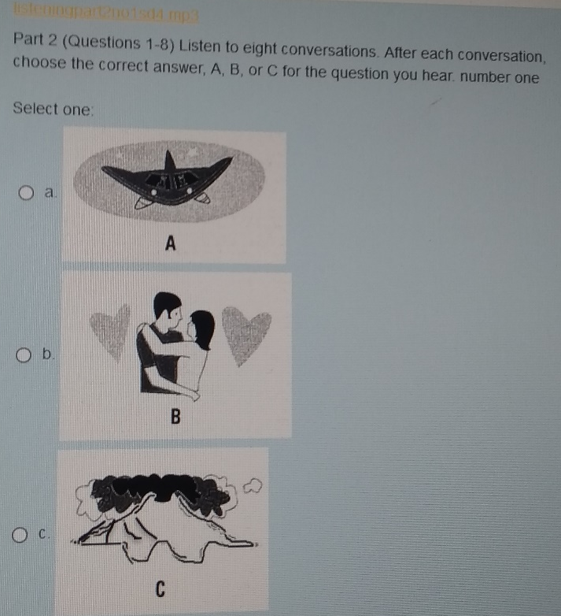

Question 10 – JAWABAN: A
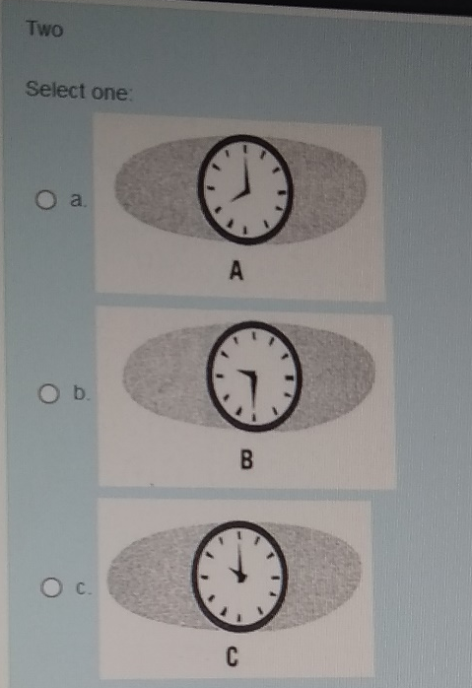

Question 11 – JAWABAN: C

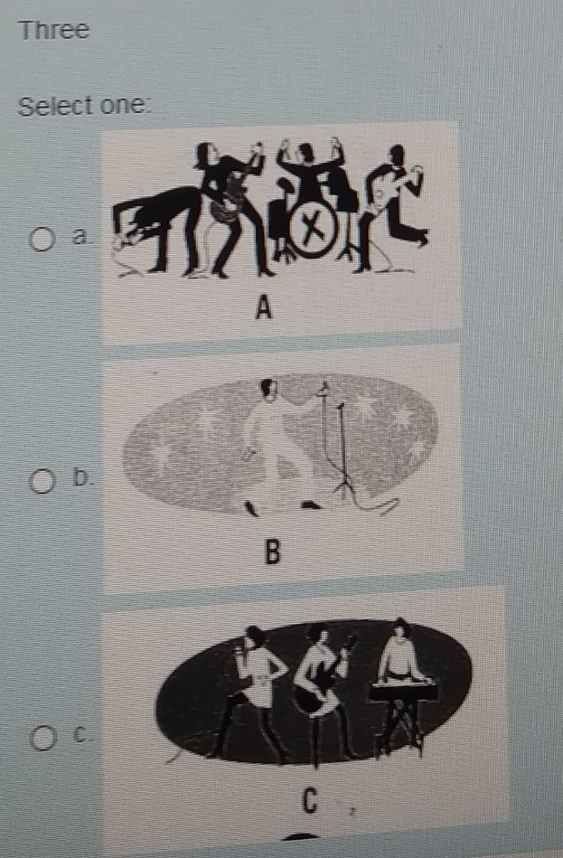

Question 12 – JAWABAN: B
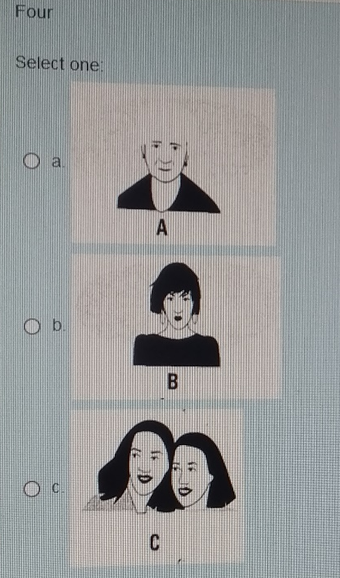

Question 13 – JAWABAN: A

Question 14 – JAWABAN: A
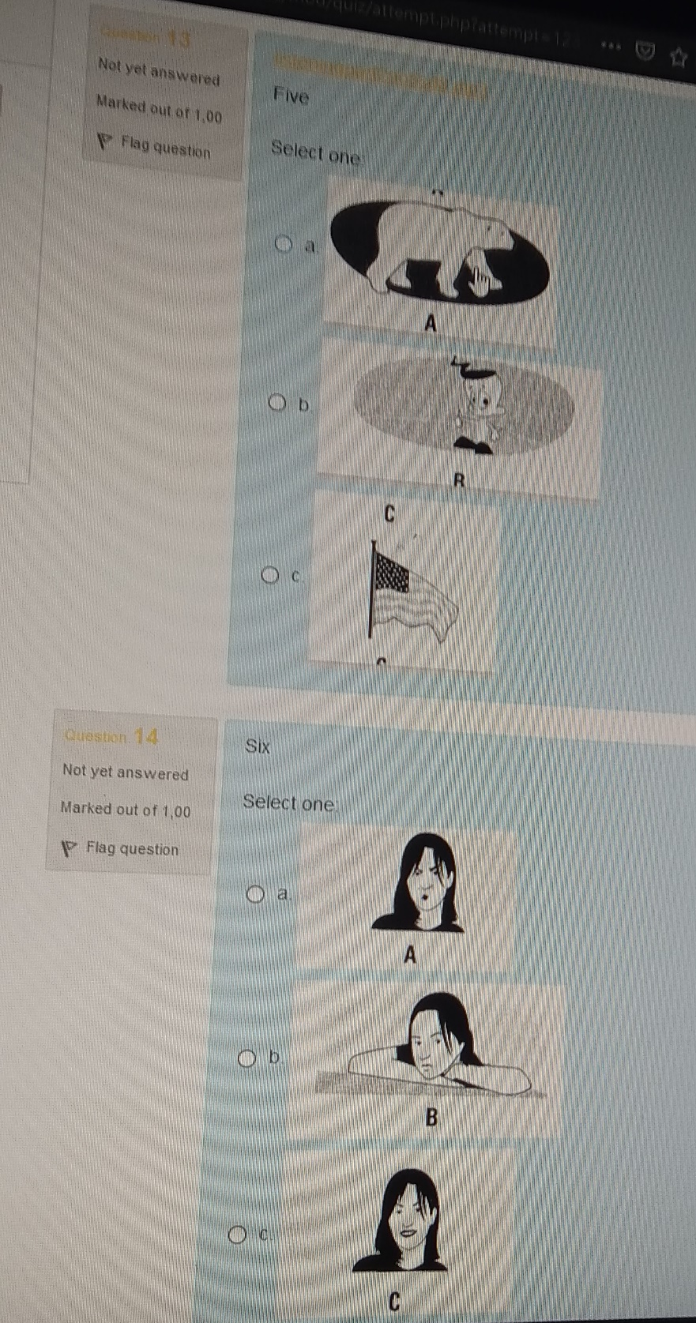

Question 15 – JAWABAN: C

Question 16 – JAWABAN: C
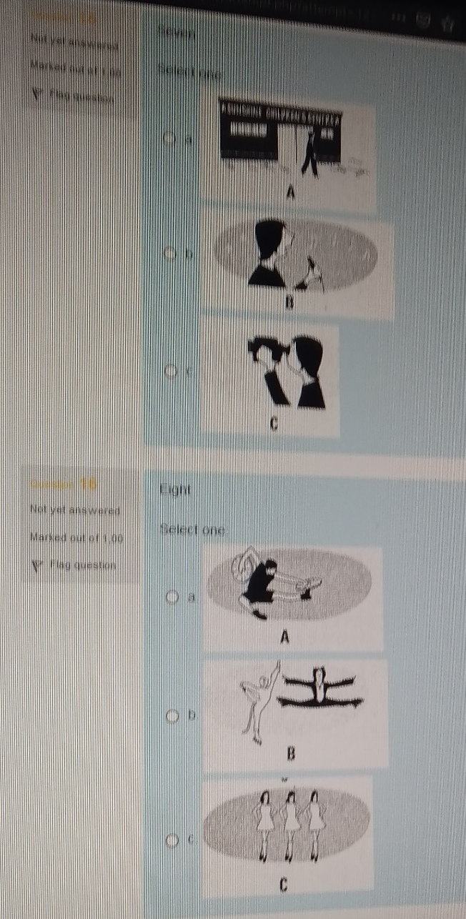

listeningpart3.mp3
Part 3 (Questions 1-7) Listen to the interview with Maria and choose the correct answer A, B or C. Maria is interested in studying the effects of peer pressure because

Question 17
Select one:
a. it causes teenagers a lot of problems
b. very few people have studied the topic
c. she has had personal experience of it

Question 18
Maria found that teenagers influence each other most in
Select one:
a. their clothes
b. their behavior
c. their work

Question 19
Maria suggests that she was influenced by a group at school because she felt
Select one:
a. unsure of what she wanted
b. attracted to what the group did
c. scared of annoying the group

Question 20
Maria says that the best way to deal with peer pressure is to
Select one:
a. ignore it and make other friends
b. ask somebody older than you for help
c. argue with the people putting pressure on you

Question 21
If you asked to do something wrong, Maria thinks you should
Select one:
a. think about what the possible results will be
b. suggest doing something else
c. delay giving an answer

Question 22
Maria thinks that when Tom was asked to be in a gang
Select one:
a. he should have spoken to his parents
b. he could have asked other friends to help him
c. he ought to have told one of his teachers

Question 23
Maria thinks a group can be a positive influence when
Select one:
a. they all choose to work hard at school
b. they have a good relationship with each other
c. they have respect for their families

listeningpart4no1sd2.mp3

Question 24
Part 4 (Questions 1- 8) Listen to people talking in eight different situations and choose the correct answer A, B, or C.You will hear the extract TWICE. You hear a student talking about his subjects at school. Why does he like physics?
Select one:
a. He hopes it will enable him to invent something
b. He enjoys the fact that it deals with concepts
c. He likes learning about how the world functions

Question 25
You hear two students talking about sci-fi films. Which film do they say has the best special effects?
Select one:
a. Pirates of the Caribbean
b. The Lord of the Rings
c. The Matrix

listeningpart4no3sd4.mp3

Question 26
You hear a teacher talking on the radio about the future of learning. What does he suggest video will be used for?
Select one:
a. allowing students to make films
b. allowing students to monitor their own progress
c. monitoring students in the classroom from a distance

Question 27
You hear a woman talking on the radio about her work. Which field does she now work in?
Select one:
a. Geology
b. Biology
c. Chemistry

listeningpart4no5sd6.mp3

Question 28
You hear two people talking about space travel. What does the man think about space travel?
Select one:
a. He is worried about the pollution it will cause
b. He disapproves of the amount of money spent on it
c. He is concerned about safety in spaceships

Question 29
You hear a woman talking at a reward ceremony. Who was to be responsible for the invention?
Select one:
a. a young inventor
b. a photographer
c. a computer expert

listeningpart4no7sd8.mp3

Question 30
You hear a woman talking about her mobile phone. What does she think about her new phone?
Select one:
a. It is too expensive for her needs
b. It has too many complicated features
c. It is too heavy for everyday use

Question 31
You hear an announcement on the radio about a science programme. How does the professor think robots will develop?
Select one:
a. They will be used in domestic situations
b. They will be sent into dangerous situations
c. They replace certain jobs in the office

listeningpart5.mp3

Question 32
Part 5 (Questions 1- 10) Listen to an interview about using films, television and celebrities for advertising and complete the sentences. Companies use films and TV to sell products because
Select one:
a. they are practical
b. they are watched by millions of people
c. everyone has a TV

Question 33
Films are best for marketing:
Select one:
a. luxury watches
b. wallet
c. shoes

Question 34
TV programs are best for selling things like
Select one:
a. soap
b. cereal
c. fashion product for teenagers

Question 35
Compared to traditional way of advertising product, TV can increase the sales of some products by
Select one:
a. 20 %
b. 30 %
c. 800%

Question 36
Chef Jamie Oliver TV show increased the sales of
Select one:
a. food product
b. kitchen equipment
c. cleaning product

Question 37
Most companies use celebrities to advertise their products because
Select one:
a. they are good looking
b. they often appear in pubic
c. they are good at persuading people

Question 38
Celebrities influence people to do the following except
Select one:
a. have a fantasy about the product
b. pay more for the product
c. take selfie pictures

Question 39
Actors like advertising products because
Select one:
a. they become more famous
b. they get more chances to start a film
c. a and b are correct

Question 40
When choosing a celebrity to advertise products, companies must
Select one:
a. consider the level of his/her popularity
b. think whether the celebrity is suitable for the product image
c. do a market survey first

Question 41
Why sport stars and actors are best for selling products?
Select one:
a. because people admire them
b. because they are good looking
c. because they work hard

